

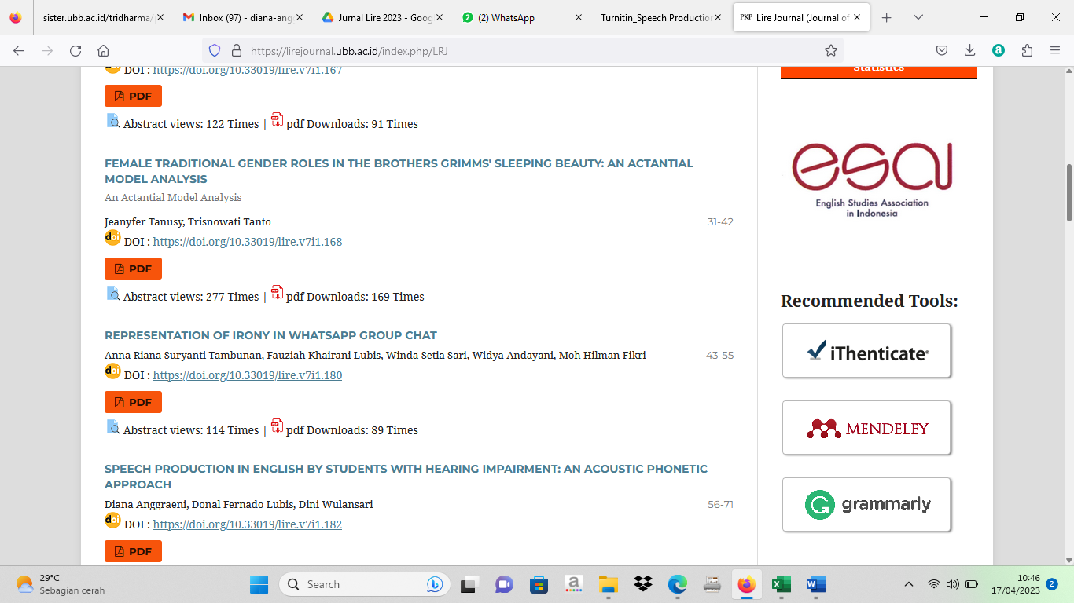

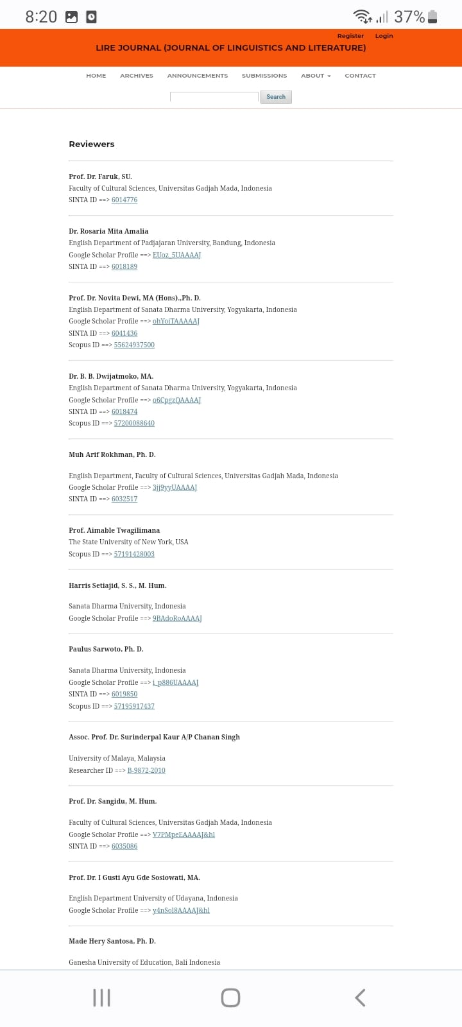

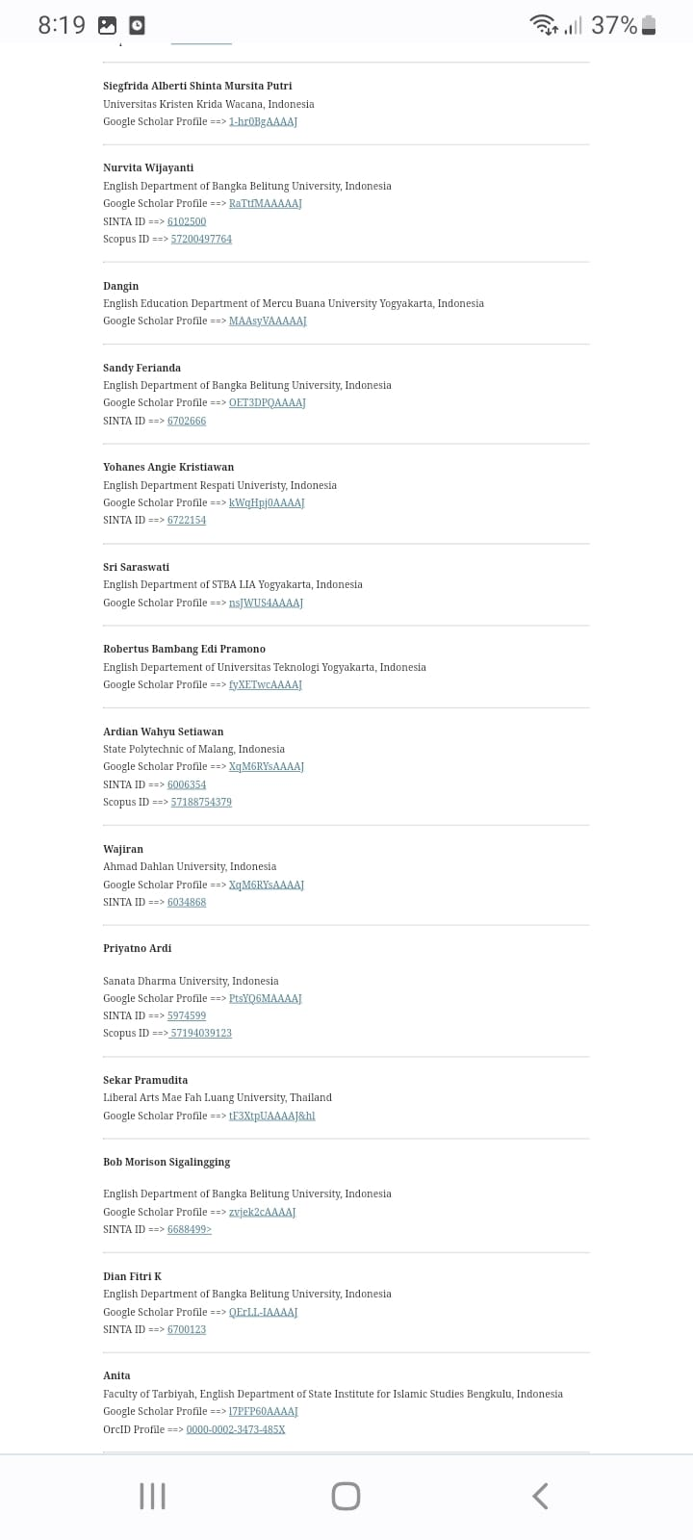

| **Link Jurnal** | **Link Repository** |
| --- | --- |
| https://lirejournal.ubb.ac.id/index.php/LRJ/article/view/182 | http://repository.ubb.ac.id/7384/ |