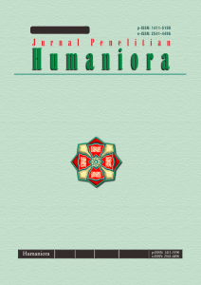

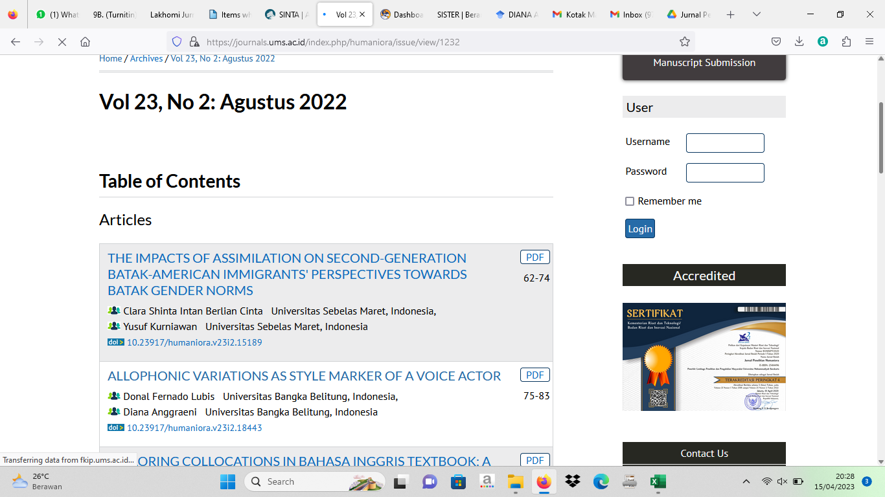

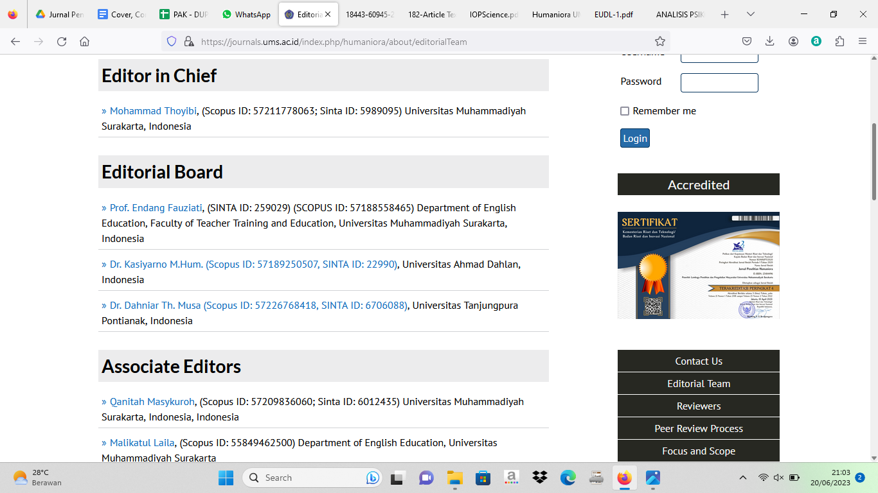

| **Link Jurnal** | **Link Repository** |
| --- | --- |
| <https://journals.ums.ac.id/index.php/humaniora/issue/view/1232> | **http://repository.ubb.ac.id/7373/-** |