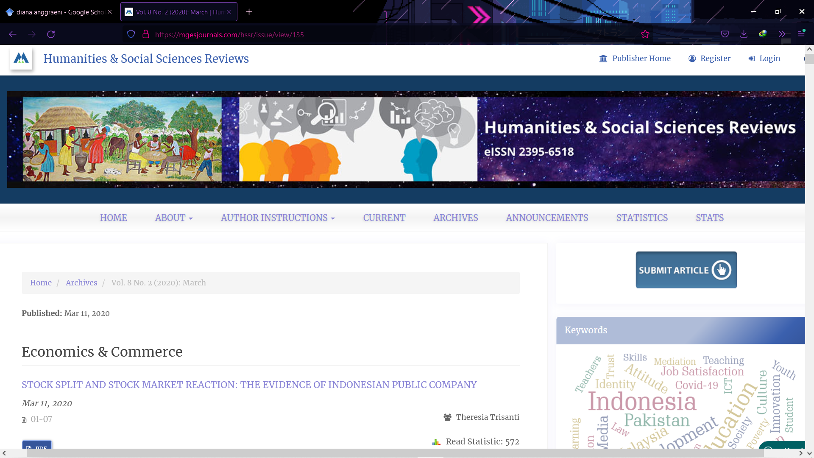

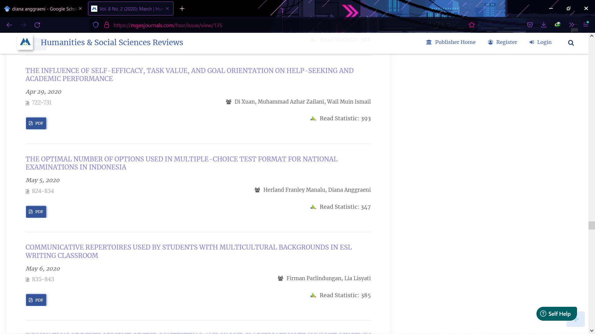

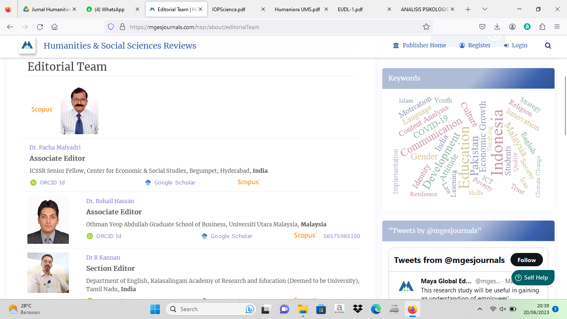

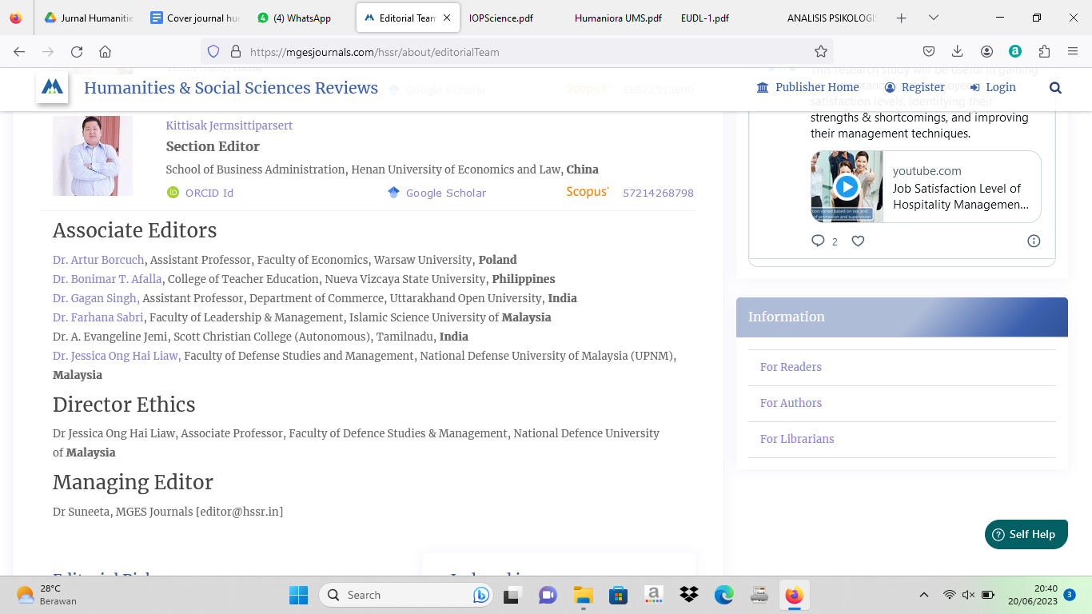

| **Link Jurnal** | **Link Repository** |
| --- | --- |
| https://core.ac.uk/download/pdf/327122505.pdf | <http://repository.ubb.ac.id/7376/> |