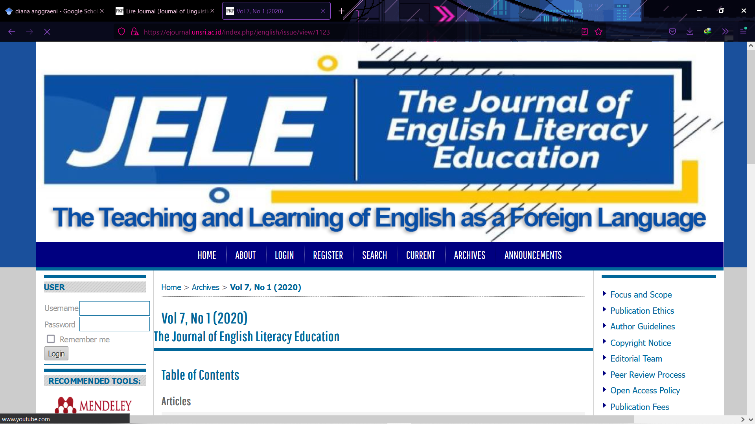

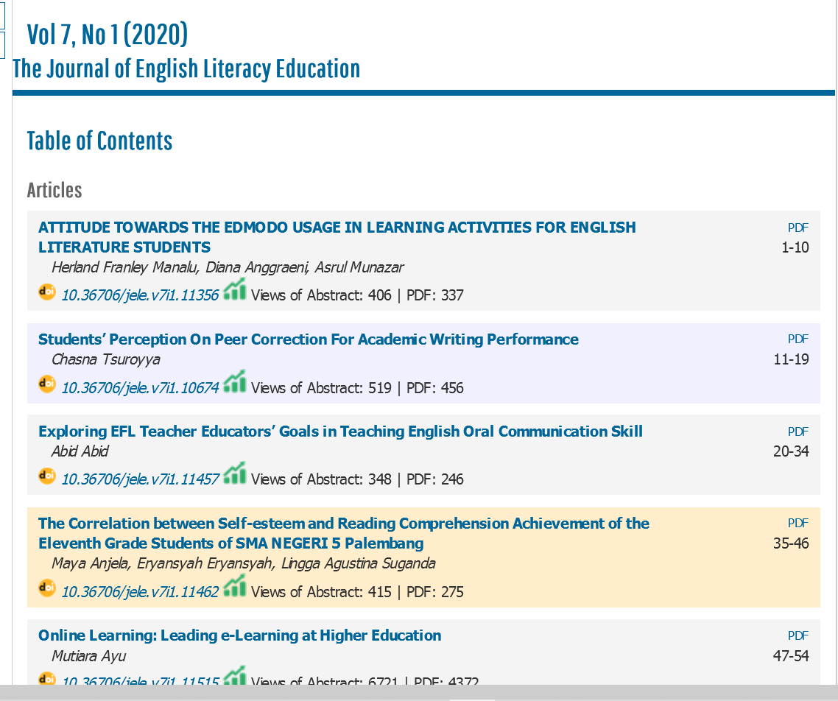

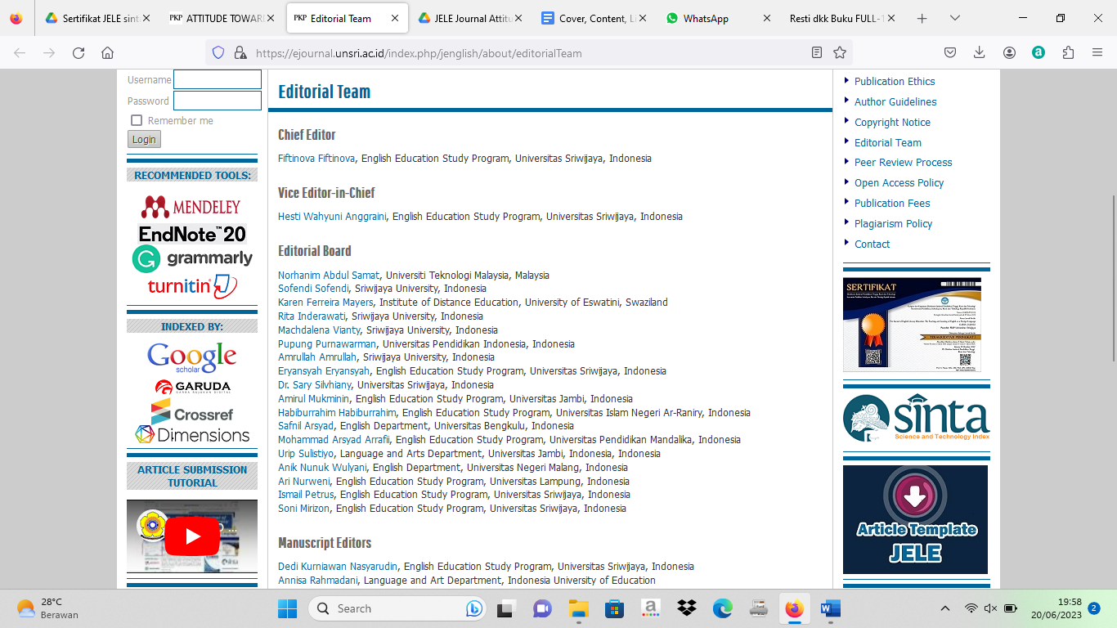

Link Jurnal | Link Repository
https://ejournal.unsri.ac.id/index.php/jenglish/article/view/11356 | http://repository.ubb.ac.id/7283/

