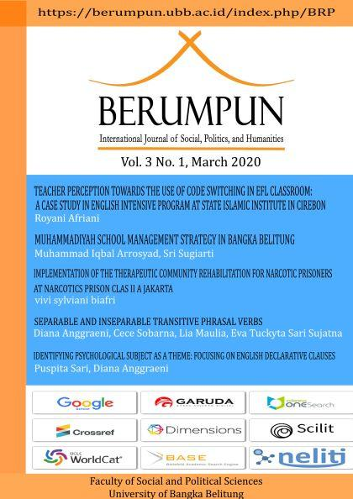

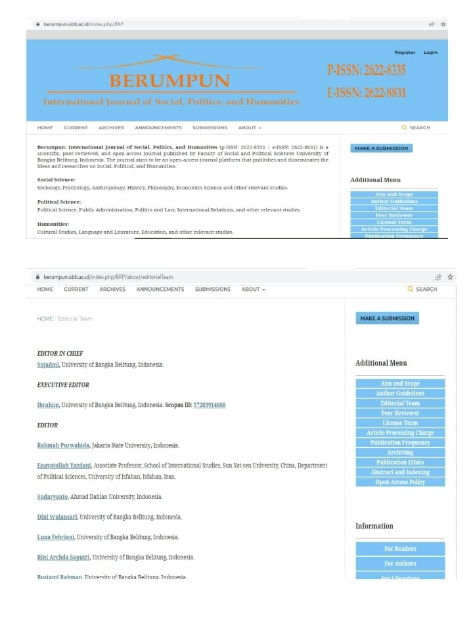
Link Jurnal | Link Repository
https://mail.berumpun.ubb.ac.id/index.php/BRP/issue/view/4 | http://repository.ubb.ac.id/7279/

