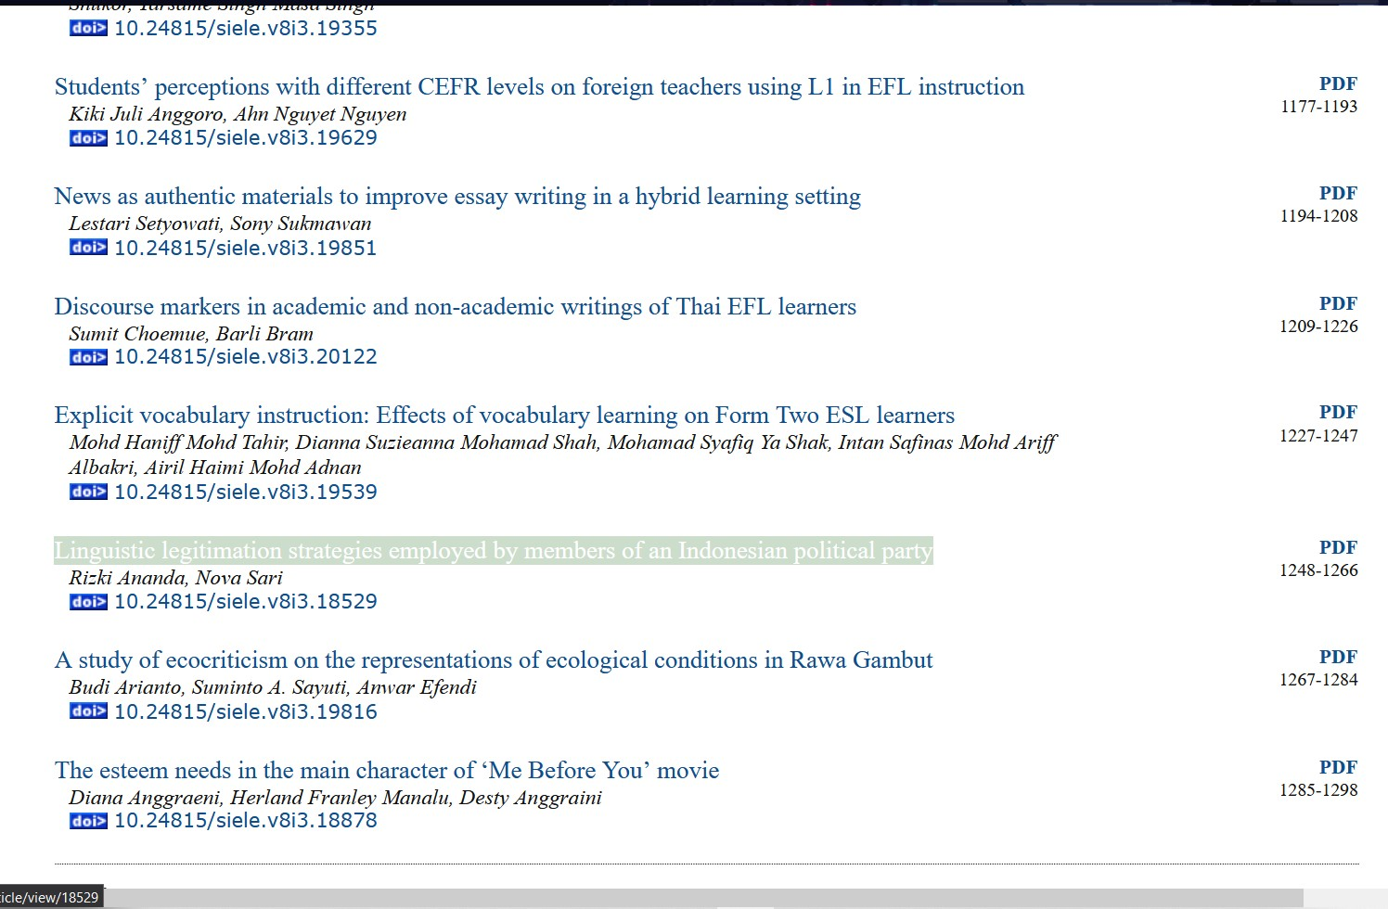

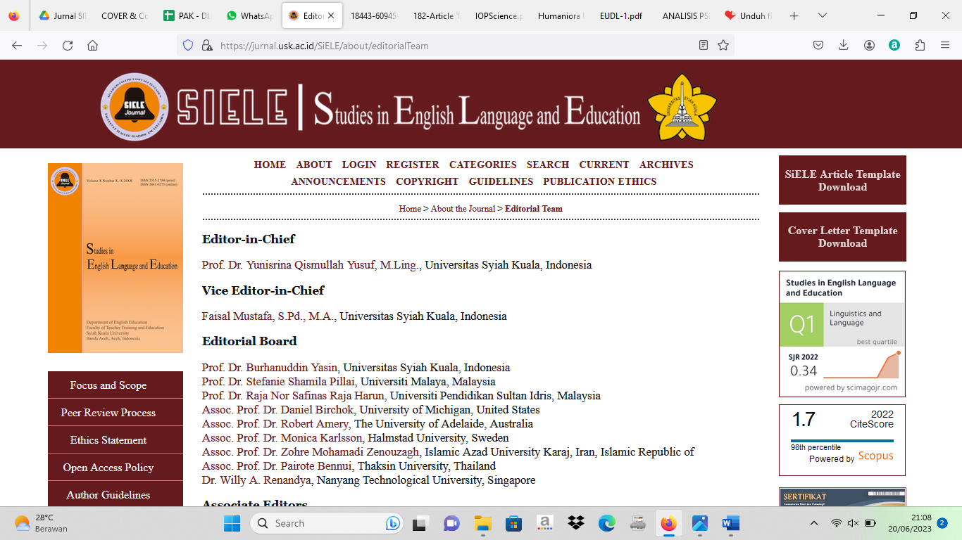
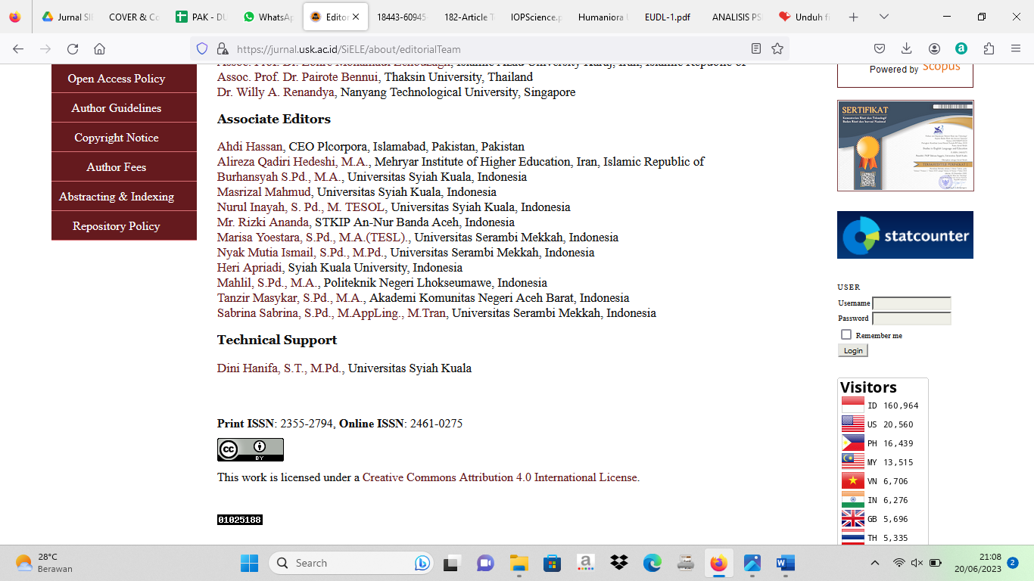

Link Google Drive | Repository UBB
https://drive.google.com/drive/u/1/folders/1v6jSgKJK0teVK8aKnPPCwkWK22TZ71bB | http://repository.ubb.ac.id/7244/

